Ideation Phase
Brainstorm & Idea Prioritization Template

Date | 11 September 2026
Team ID | NA
Project Name | Metro Ticket Generating System in ServiceNow
Maximum Marks | 4 Marks

Step-1: Team Gathering, Collaboration and Select the Problem Statement
Goal & Focus
Build an enterprise-grade digital ticketing system on the ServiceNow Service Portal to eliminate manual counter lines, automate route-based fare collection, and issue instant, scannable QR gate entry passes.
How Might We (HMW) Statement
"How might we digitize and streamline the metro ticket booking process using ServiceNow so commuters can calculate fares automatically and receive an instant, scannable QR ticket on any device?"
Key Rules of Brainstorming Adhered to:
- Stay in Topic: Keep ideas strictly centered on passenger commute experience, ticket accuracy, and gate turnstile scannability.
- Defer Judgment: Log all distribution channels (Service Portal, WhatsApp, SMS, Kiosks, Smart Cards) before filtering.
- Encourage Wild Ideas: Explore turnstile automation, dynamic Surge Pricing, and automated modal interceptors.
- Go for Volume: Compile a broad set of ideas across UX, scripting logic, data layers, and delivery channels.
- Be Visual: Map ideas onto an interactive 2×2 Importance vs. Feasibility grid.
Step-2: Brainstorm, Idea Listing and Grouping
Individual Brainstormed Ideas (Sticky Notes Pool)
- Idea 01: Service Portal catalog item for booking metro tickets directly from web or mobile (/sp).
- Idea 02: Custom database table storing metro station master data (u_metro_station_details).
- Idea 03: Client-side dynamic fare computation calculating rates based on Source, Destination, and Passengers.
- Idea 04: Modal pop-up dialog (spModal) rendering a dynamic scannable QR code token.
- Idea 05: Support for return journeys with automatic rate calculation.
- Idea 06: Dynamic UI policy showing extra input fields when "Others" is selected as the payment mode.
- Idea 07: Integration with external SMS gateways (Twilio) to send digital passes via text message.
- Idea 08: WhatsApp Business API integration to dispatch PDF tickets with QR codes.
- Idea 09: IoT hardware integration reading turnstile NFC chips with ServiceNow inbound webhooks.
- Idea 10: Automated fare collection using real-time GPS location tracking.
- Idea 11: Commuter travel history dashboard inside Service Portal user profiles.
- Idea 12: Role-based Access Control Lists (ACLs) to secure station master tables from public edits.
Idea Grouping (Clustered Themes)
- Group A: Core ServiceNow Portal & Form Engine (P0 / Baseline)
  - Service Catalog booking item (Book A Metro Ticket).
  - Master station lookup table (u_metro_station_details).
  - Conditional UI policy for payment mode breakdown (enter_payment_mode).
  - Custom modal dialog (spModal) rendering interactive tickets.
- Group B: Dynamic Fare & Automation Logic (P0 / Core)
  - onChange Catalog Client Script running the route matrix fare table.
  - Real-time calculation for Single Journey (type_of_journey = 1) and Return Journey (type_of_journey = 2).
  - onSubmit script intercepting form checkout to trigger dynamic 2D QR generation.
- Group C: Omnichannel & Delivery Integrations (P1 / Intermediate)
  - Ticket dispatch via SMS/Email notifications.
  - WhatsApp Business API integration for pass delivery.
  - Travel history summary widget for commuter portals.
- Group D: Hardware & Advanced Transit Infrastructure (P2 / Future)
  - Physical station turnstile IoT integration with REST APIs.
  - Commuter GPS-based automated gate checkout.

Step-3: Idea Prioritization
Prioritization Matrix (Importance vs. Feasibility)
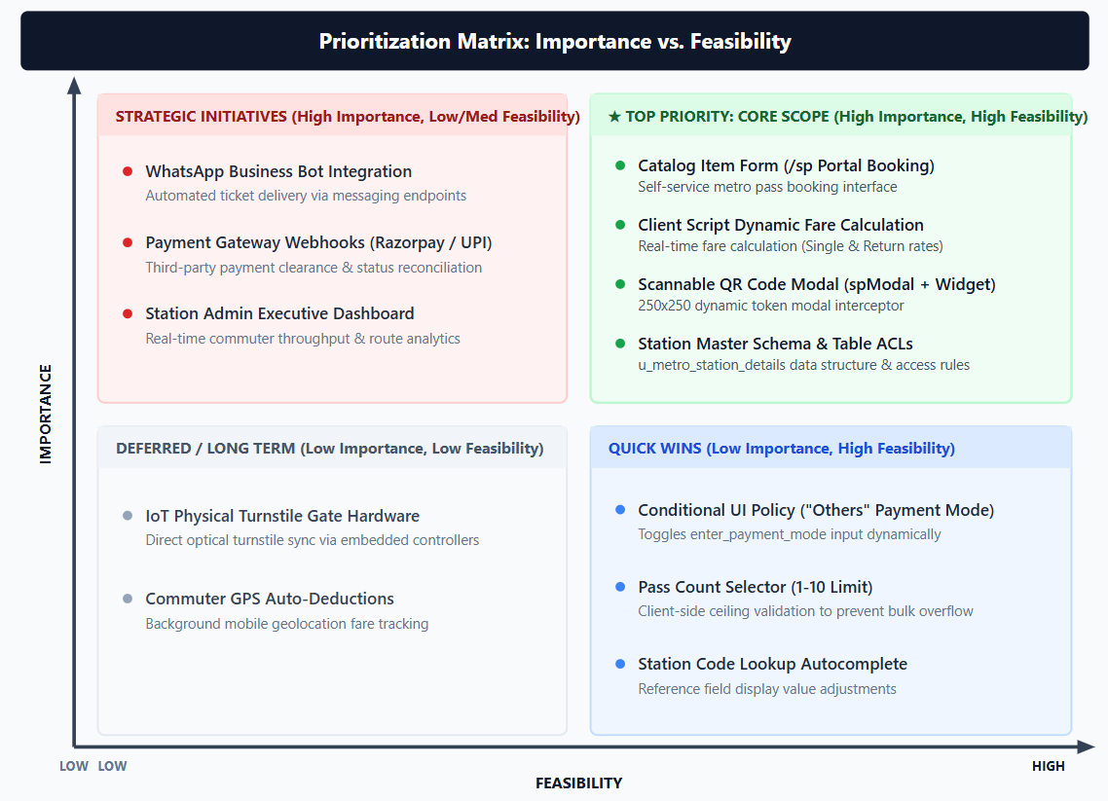
Prioritized Implementation Actions:
- P1 (Core Solution - Immediate Scope): Build the Service Catalog Item, master database tables, onChange fare matrix script, and the spModal QR rendering widget (metro_qr_widget).
- P2 (Secondary Enhancements - Phase 2): Add SMS/Email notifications with ticket details and store historical travel records.
- P3 (Future Scope - Long Term): Integrate payment gateways and connect physical IoT gate turnstiles using ServiceNow Inbound Scripted REST APIs.
Diagram 1: Step-2 Brainstorm & Idea Grouping (Canvas Board)
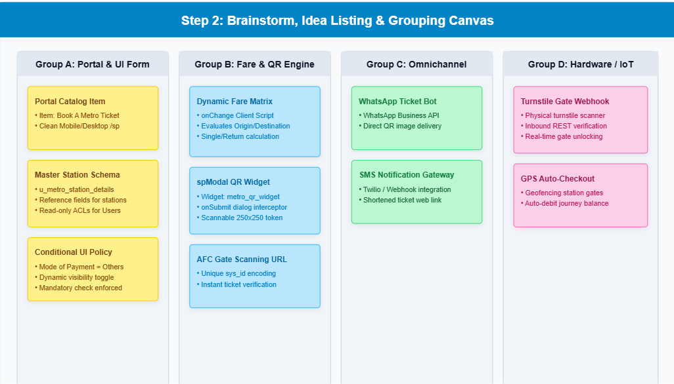
Diagram 2: Step-3 Idea Prioritization Grid (Image 3 Template Matching)

